

Project Based ‘J’ Component
Winter Semester 2022-23

Course Name: Operations Analytics

Course Code: MGT3014

Slot: C2+TC2

Title: “PRODUCT SEGMENTATION IN RETAIL STORES”

Submitted by:
Abhishek Kasam - 19MIA1081
Sree Reddy – 19MIA1057
Arvind Reddy – 19MIA1089
Venkat Reddy – 19MIA1104

Submitted to
Dr. Sudarsanam.K
VIT Business School
Vellore Institute of Technology, Chennai
INDEX

S.no | Topic | Page.no
1. | Introduction | 3
2. | Problem Statement | 4
3. | Work Flow | 4
4. | Scope / Dataset | 5-8
5. | Objective | 9
6. | ABC Analysis  (Segmentation with results explained) | 10-14
7. | Demand Stability: Coefficient of Variation  (Segmentation along with results) | 14-19
8. | Conclusion | 20

INTRODUCTION
Product segmentation refers to the activity of grouping products that have similar characteristics and serve a similar market. It is usually related to marketing (Sales Categories) or manufacturing (Production Processes)
However, as a Logistics Manager, you rarely care about the product itself when managing goods flows; except for the dangerous and oversized products.
Your attention is mainly focused on the sales volume’s distribution (fast/slow movers), demand variability and delivery lead time.
we want to put efforts into managing products that have:
- The highest contribution to your total turnover: ABC Analysis
- The most unstable demand: Demand Variability
In this project, we introduce simple statistical methods to combine ABC Analysis and Demand Variability to perform products segmentation.

PROBLEM STATEMENT

We are the Operational Director of a local Distribution Centre (DC) that delivers 10 Hypermarkets.
In our scope Operational Director have the responsibility of
- Preparation and delivery of replenishment orders from stores
- Demand Planning and Inventory Management

WORK FLOW
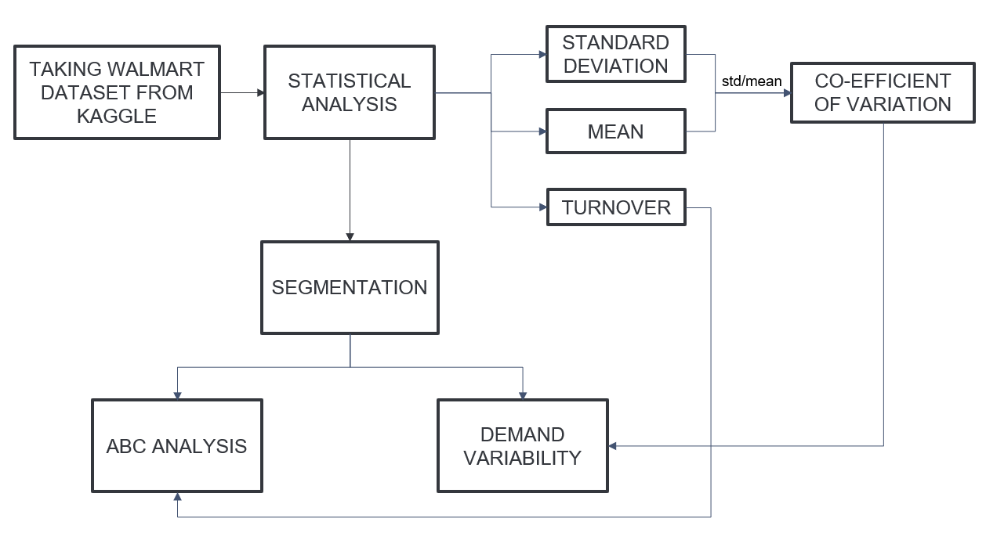
SCOPE/DATASET
This analysis will be based on the M5 Forecasting dataset of Walmart stores’ sales records (Link).
We suppose that we only have the first-year data (d_1 to d_365):
- 10 stores in 3 states (USA)
- 3,049 unique SKU
- 3 categories and 7 departments (sub-category)
Except for the warehouse layout, categories and departments have no impact on your ordering, picking or shipping processes.
Dataset:
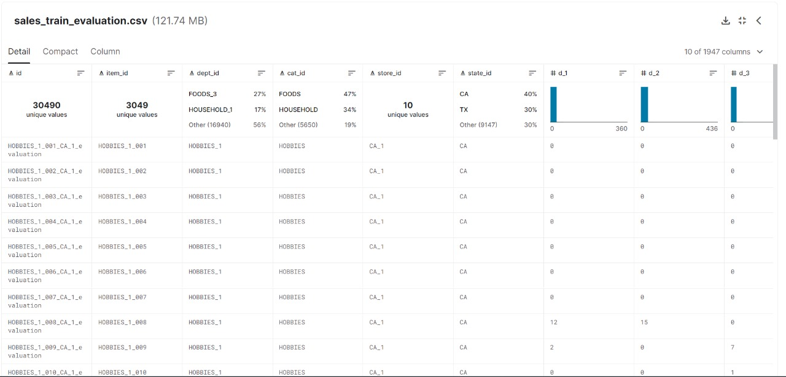
- The dataset provided contains 42,840 hierarchical sales data from Walmart. The dataset covers stores in three US states (California, Texas, and Wisconsin) and includes item level, department, product categories, and store details for 5 years starting from 29th Jan 2011 to 24th April 2016.
- The data comprises 3049 individual products from 3 categories and 7 departments, sold in 10 stores in 3 states.

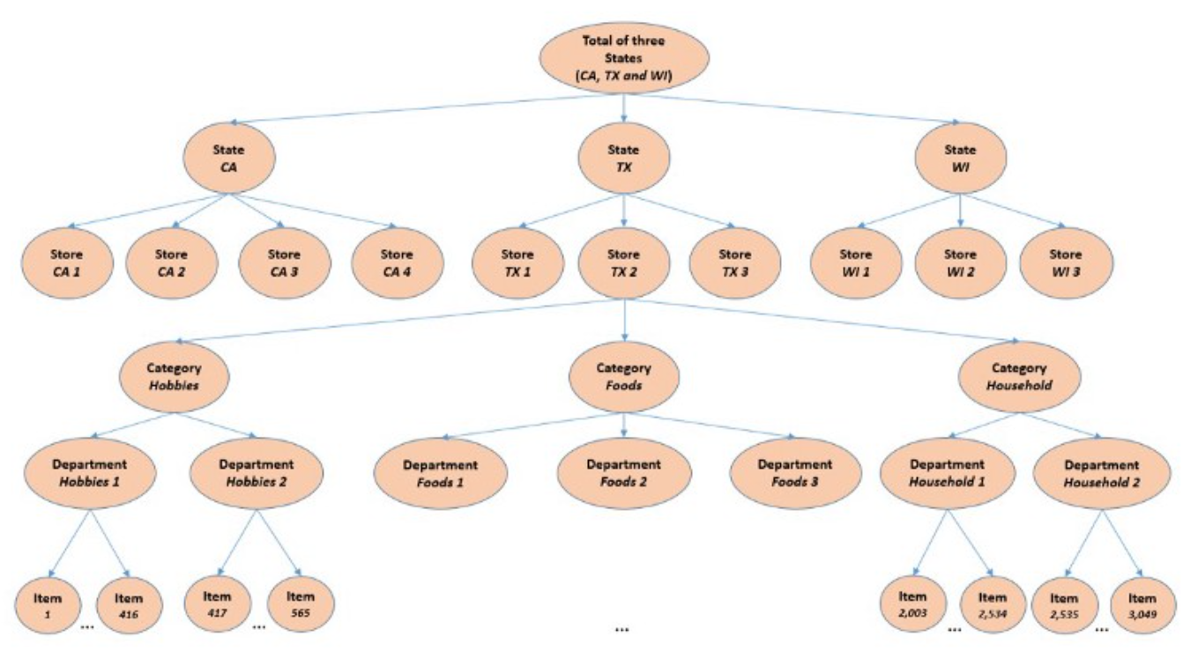
An Overview of how M5 series data is organised

Code for Data Pre-processing:
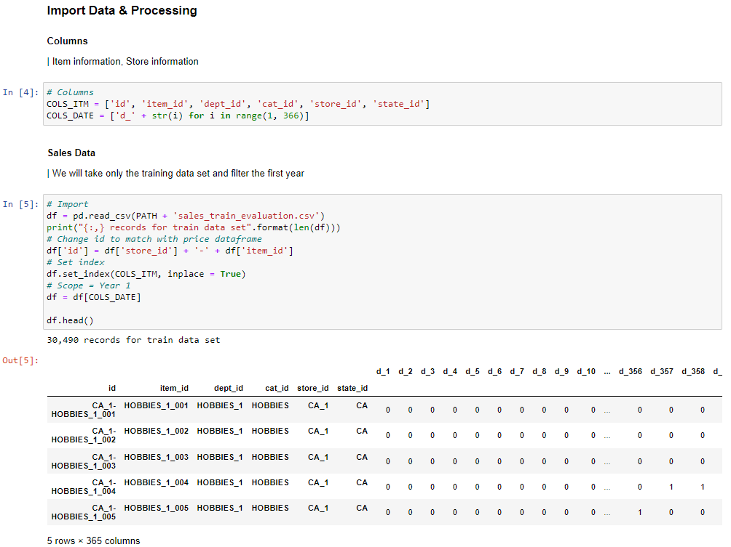
Here we will define COLS_ITM by taking the columns and COLS_DATE as range of first 365 days as we are taking data for the first year.
Next, we will import sales_train_evaluation training dataset.
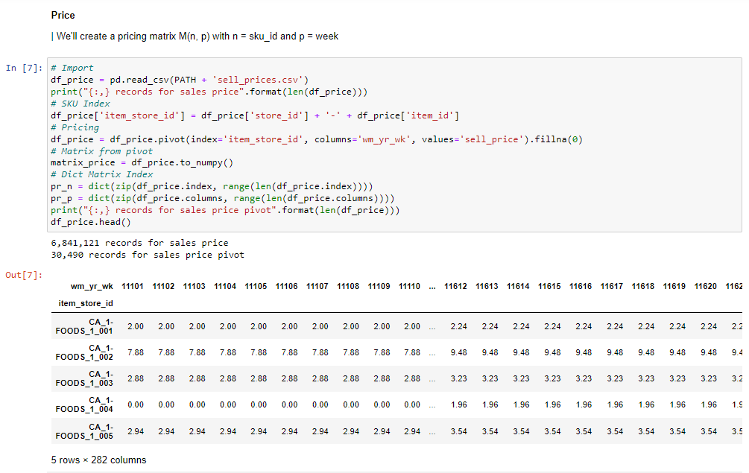
We will use sell_prices dataset for assigning the price for each product in the 5 years.

OBJECTIVE
What does impact your logistic performance?
Products Rotation
What are the references that are driving most of your sales?
- Top 10% products (Class A)
- The following 20% products (Class B)
- The remaining 70% products (Class C)
Demand Variability
How stable is your customers’ demand?
- Average Sales: µ
- Standard Deviation:
- Coefficient of Variation: CV = σ/µ
For SKUs with a high value of CV, you may face unstable customer demand that would lead to workload peaks, forecasting complexity and stock-outs.

Code:
- Filter on the first year of sales for HOBBIES Skus
- Calculate Mean, Standard deviation and CV of sales
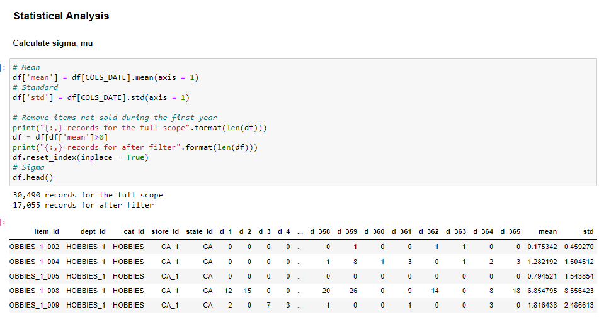
Here the mean and standard deviation is calculated and in the output we have got a mean & std column for every item for the 1st year.
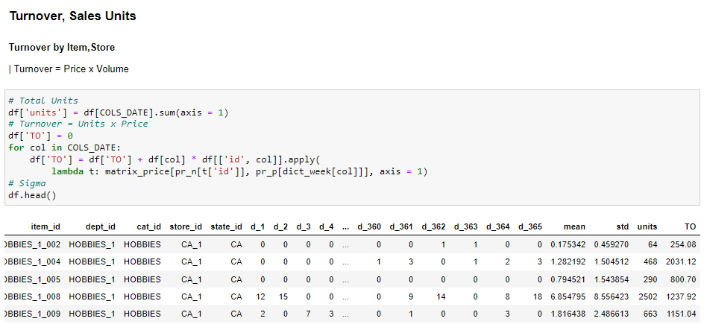
Here we are calculating Turnover for every product in the 1st year using the formula Turnover = Units x Price (as we calculated price above) and we can also see in the output that turnover column is added.
Here total no of units means in that one year how many products for that particular ID are sold and price refers to the price of that product.

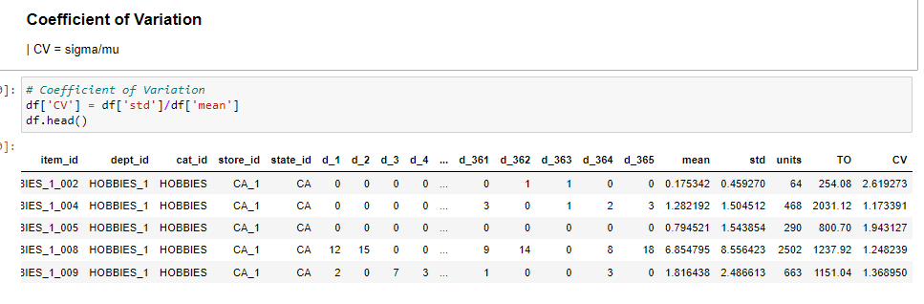
Demand variability in supply chain is a measurement of how much variability can occur in the demand from customers
we use coefficient of variation (COV) for calculating demand variability that is the formula for the COV is S.D/MEAN
we have to take the absolute mean values as we get CV as positive number which helps us to determine if the SD is small or large and compared to the mean.

SEGMENTATION METHODS EXPLAINED ALONG WITH RESULTS:
This analysis will be done for the SKU in the HOBBIES category.
- ABC ANALYSIS:
What are the references that are driving most of your sales?
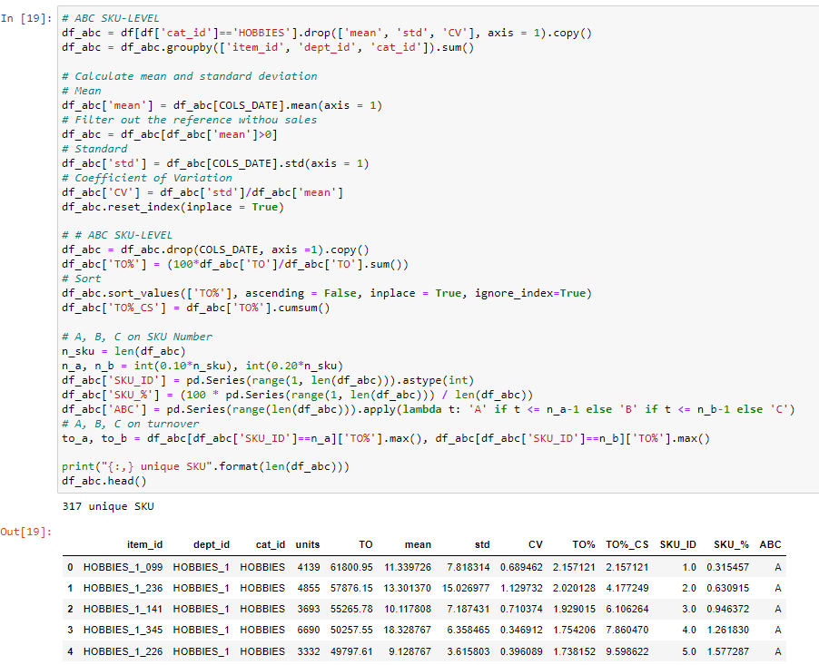
Coming to ABC analysis here we took only Hobbies category and we have to calculate Turnover percentage = multiplying the particular turnover x 100/total turnover.
we have to assume the sku ID for the unique SKU's of Hobbies category
we have to calculate SKU % = multiplying sku id X 100/total SKU units.
After calculating these all we have to classify all the products based on the condition because ABC is used to prioritize the items
here first 10% will be classified as ‘A’ and next 20% will be classified as ‘B’ and next 70% is classified as ‘C’.
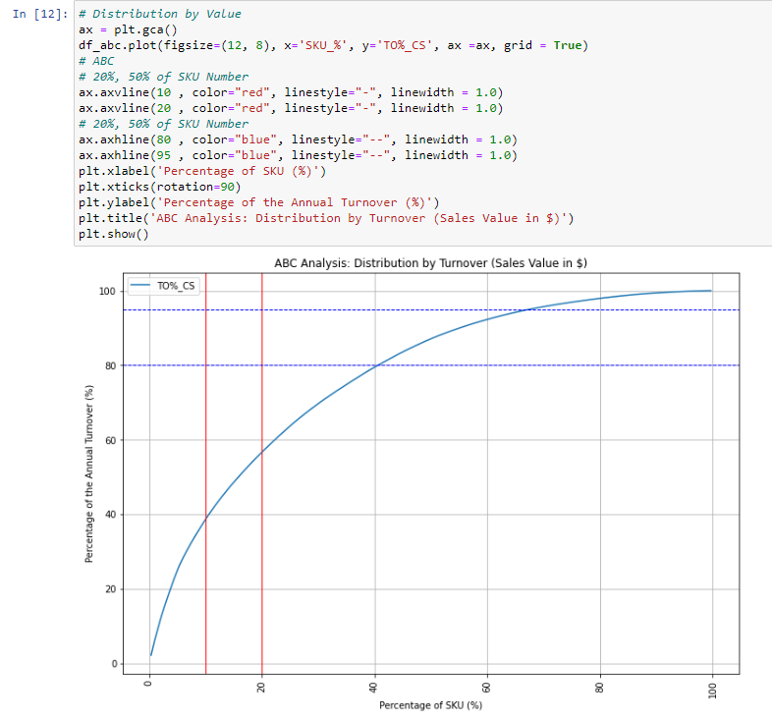
Class A: the top 10%
- Number of SKU’s: 32
- Turnover (%): 38%(0 - 10% of sku)
Class B: the following 20%
- Number of SKU’s: 31
- Turnover (%): 19%(11 – 20% of sku)
Class C: remaining 70%
- Number of SKU’s: 254
- Turnover (%): 33%(21-100% of sku)

- DEMAND STABILITY: COEFFICIENT OF VARIATION
How stable is your customers’ demand?
From the Logistics Manager's point of view, it is way more challenging to handle a peak of sales than a uniform distribution throughout the year.
In order to understand which products will bring planning and distribution challenges, we will compute the coefficient of variation of the yearly distribution of sales of each reference.

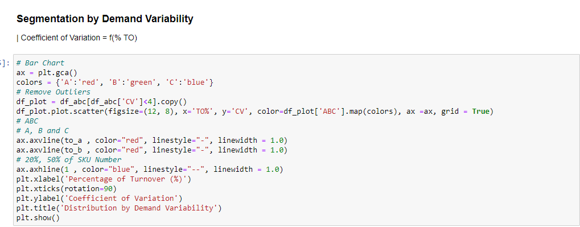
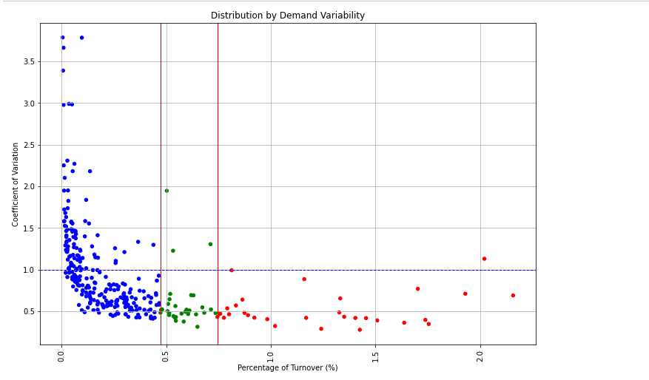

The points in red color are of the Class A. Since they have high turnover ratio, they are at the end of the graph.
The points in green are of Class B. Since they have medium turnover ratio, they are at the middle of the graph.
The points in blue are of Class C. Since they have low turnover ratio, they are at the start of the graph
We can also see that the CV values of the products from class A – class C are increasing.
Class A have only one product with CV>1
Class B have three products with CV>1
Whereas Class C have many values with high CV.
Class C also have many products with low CV.
It indicates that many products in Class – C are also having stable demand. But the turnover ratio which the low CV items in class – C provides is very less when compared to Class-B and Class-A.

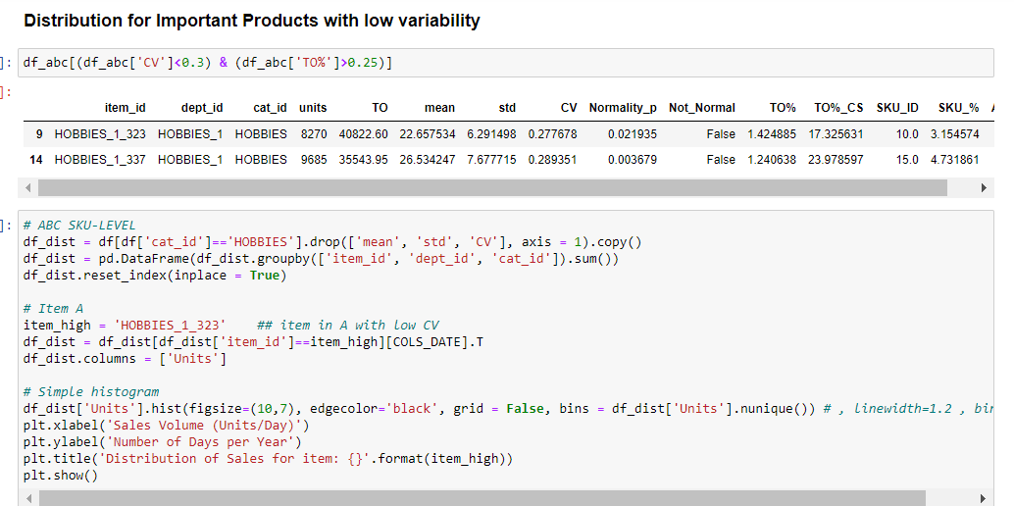
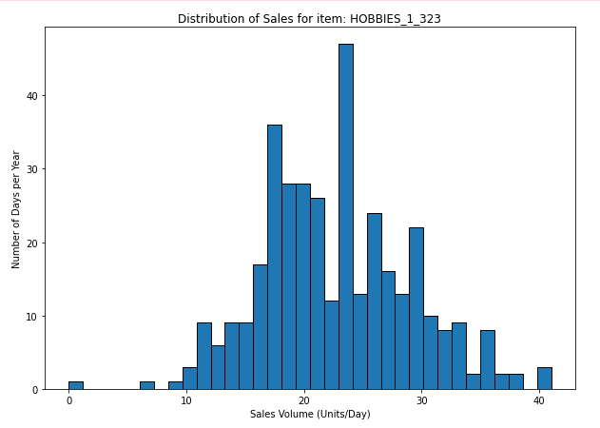
We can see that there is stable demand for a product in Class A.
So that we won't be challenged by Class A products in planning or managing the stock.
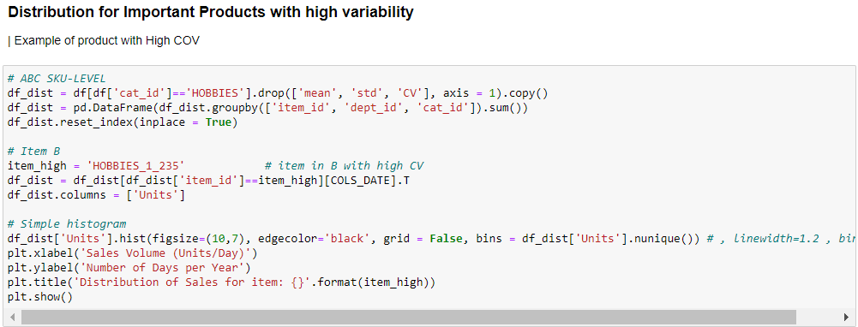
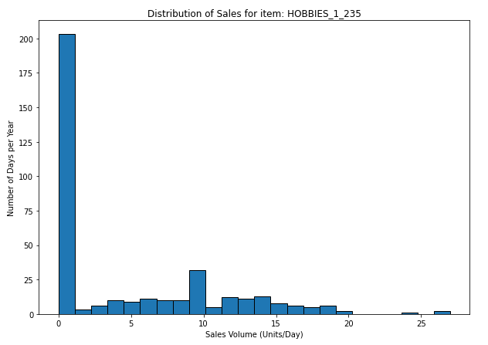
For Class B product there is slightly stable demand.
So, we need to spend some effort in planning for some high cv products in class B
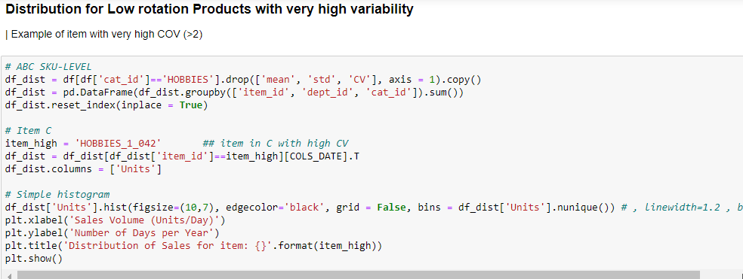
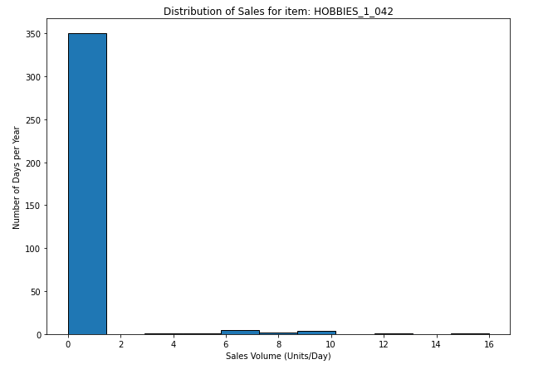
Whereas there is completely unstable demand for a product in Class C
So, we need to spend more efforts in planning and managing the products in Class C

CONCLUSION
Finally, we have done the ABC analysis and segmented the products into three classes.

Class A: the top 10%
- Number of SKU’s: 32
- Turnover (%): 38%(0 - 10% of sku)
Class B: the following 20%
- Number of SKU’s: 31
- Turnover (%): 19%(11 – 20% of sku)
Class C: remaining 70%
- Number of SKU’s: 254
- Turnover (%): 33%(21-100% of sku)
we have also found which particular products in each Class (A, B, C) will bring planning and distribution challenges using Demand Variability (coefficient of variation).
This operationally driven segmentation gives us a few insights on the challenges for an operational manager or logistic manager will face for planning and managing the goods flows to meet your store's demand.

